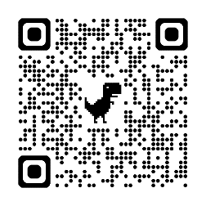


The Glaucoma Community: Join this FREE online community

Are you or someone close to you living with glaucoma? The Glaucoma Community is a FREE online or app-based community that empowers people living with glaucoma through knowledge, support, and shared experiences. Join other people like you who trust The Glaucoma Community to provide vetted medical information, a place to connect, and resources to live better.

Stay informed with your customized Newsfeed

Keep up-to-date on the latest glaucoma news with your personalized Newsfeed that features content vetted by leading experts in the medical, scientific, and patient advocacy fields.

Build connections and get community support

Connecting with other glaucoma patients and caregivers is a great way to share experiences, advice, and encouragement. You can chat with other users and post comments, photos, and videos.

Easily organize and update your medical information

Use the Patient One-Sheet to store all of your medical information and save valuable time at the doctor’s office. You can print, share, and download this easy-to-use, patient-designed dropdown form.

The Glaucoma Community is free and available via web browser or Apple iOS and Android mobile app. Learn more about how to download the app or visit the website at: https://responsumhealth.com/glaucoma/.

“This group has helped me to live with glaucoma. Because of it, I know that I'm not alone. There are people who understand and are willing to share.”

Tom Franklin, member of The Glaucoma Community

